**P4 – Design a Website**

**Mood Board**A mood board is a series of images designed to convey the ‘feel’ or ‘mood’ of the website.  
My website content will be about programming, and have a design related to programming.

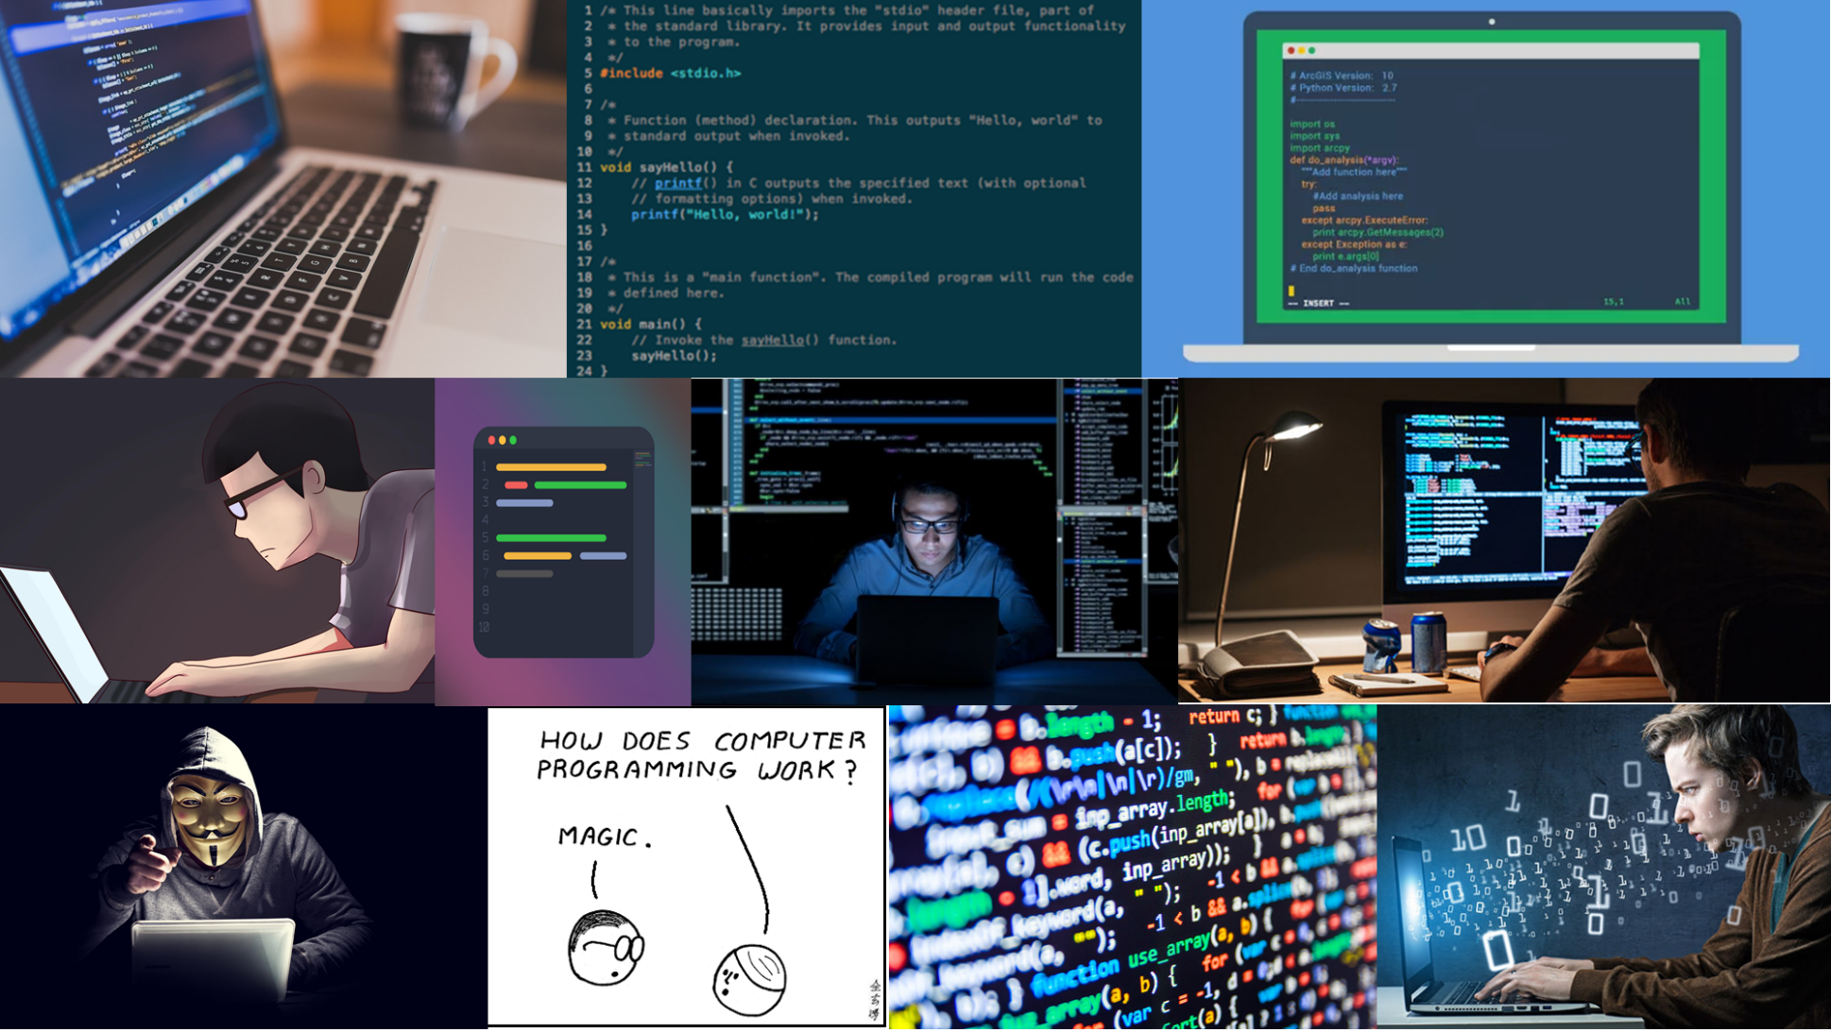

**Site Template/Storyboard.**A story board is a prototype design of the layout and content design. The following shows differing design for the front page (left) and content pages. Content has headers on the left, and is less spaced out.

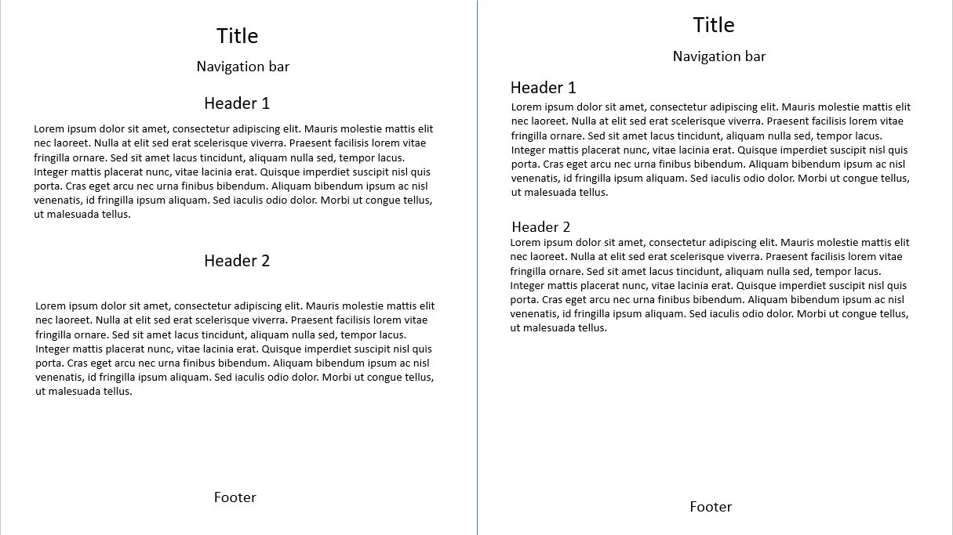

Pages on the site will include the home page, and content will cover information on various programming languages and concepts.

**Colour Scheme**  
IDE’s (software used for coding) often have a set of colour schemes. One of the most popular is ‘Solarized Dark’, which consists of the following colours.

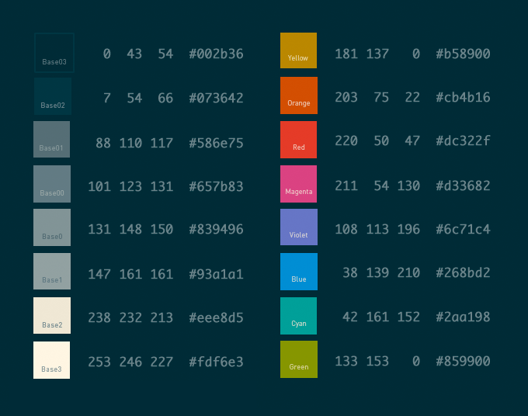Solarized has 16 colours – 8 for background and text, and 8 complimentary colours for other use.

Knowing the hexadecimal or RGB values of each colour is important, as when changing the sight design with CSS, the colour will be specified by those values.

I will use this colour scheme for the website, as It has been designed for maximum clarity and colour co-ordination, and is often used by programmers.

**Outline of Content**  
The website will have a separate page for; Python, C#, HTML, JavaScript, CSS, Object-Orientated Programming and Procedural Programming